**WRITING RULES**

1. Section main headings should be the same for all sections. Each main heading may have more than one sub-heading and each sub-heading may have sub-levels. However, the following main headings are suggested for a book chapter.

Introduction

…………..

…………..

Material and Methods

…………..

…………..

Findings

…………..

…………..

Conclusions, Dissussicon, and Suggestions (Discussion after the Findings can also be done as a separate section)

1. Book chapters should be written according to the dimensions of 16 cm in width and 24 cm in height.
2. Page margins should be set as left 2.5 cm, top-bottom-right 2 cm.
3. The main title of the text should be written in **Times New Roman** font, in all capital letters, 14 pt. and bold. The main title should be centered on the page.
4. After the main title of the text, the author's name and surname should be written in 12-point **Times New Roman** font, leaving two line spaces. Only the first letter of the author's first name and the entire surname should be capitalized. Author names should be written right justified. If there is more than one author, the names should be written side by side.
5. The title, institution, e-mail address of the author should be indicated on the first page as a footnote in 9-point Times New Roman font.
6. Leave 1 line space after author names.
7. The text should be written in Times New Roman font, 11 pt. font size and 1.15 line spacing, justified.
8. Writing the Headings in the Text

1st degree headings; only the first letters are capitalized and bold, 14 pt,

2nd degree headings; only the first letters are capitalized and bold, 13 pt,

3rd degree headings; only the first letters are capitalized and bold, 12 pt,

Sub-headings; only the first letters capitalized and bold italicized, 12 pt.

1. There is no need to give an abstract at the beginning of the text. The text can be started with an intermediate title or an “Introduction” title. Paragraflar önce 0nk, sonra 6 nk olacak şekilde düzenlenmelidir.
2. Paragraph indentation should be 0.5 cm.
3. Footnotes should be in 9-point font. Footnotes should not include references, only explanations.
4. Tables should be numbered, the title of the table should be placed above the table and written in 11 pt. Table content should be in 10 pt. and single-spaced. Tables should not be divided by sliding to the next page.
5. Figures and graphs should be numbered and all figures and graphs should be named as figures. Figure names should be written at the bottom in 11 pt.
6. Tables, figures and graphs should be cited in the text (Table 1, Figure 2, etc.).

**Table Title Example**

**Table 1.** Distribution of Children in The Validity and Reliability Study of Science Learning Assessment Test as Per Gender, Number of Siblings

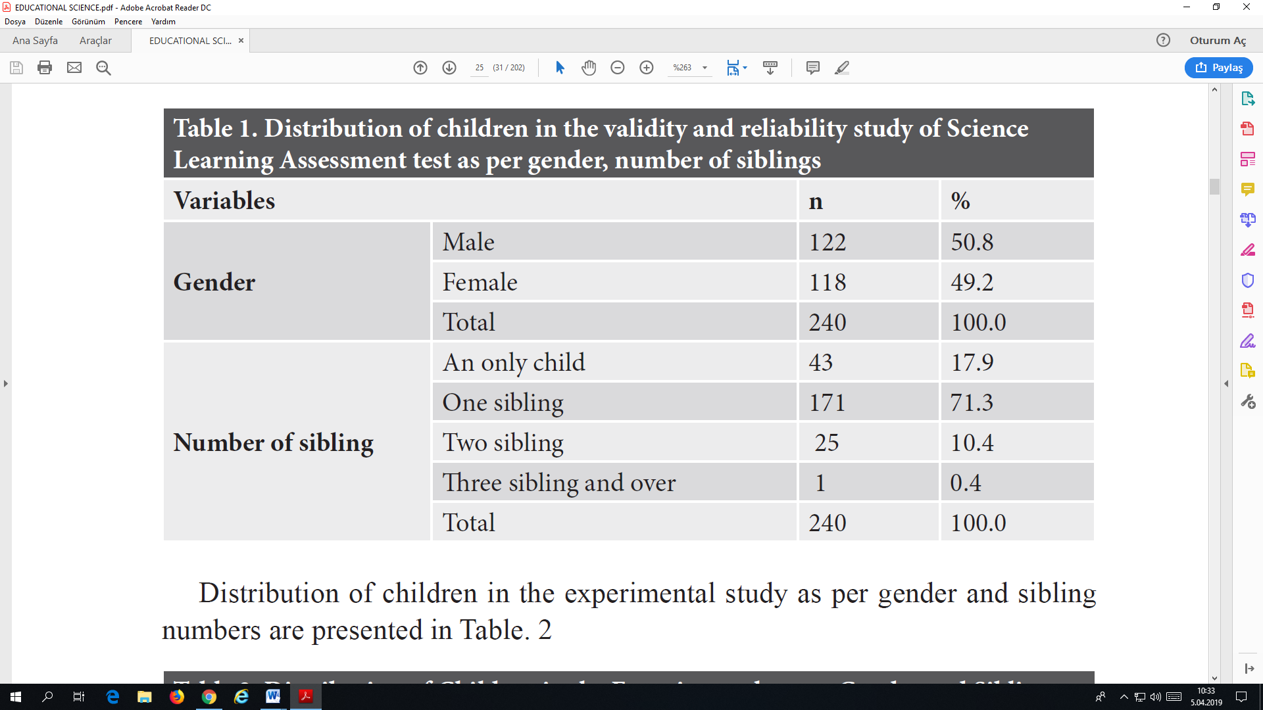

**Figure Title Example**

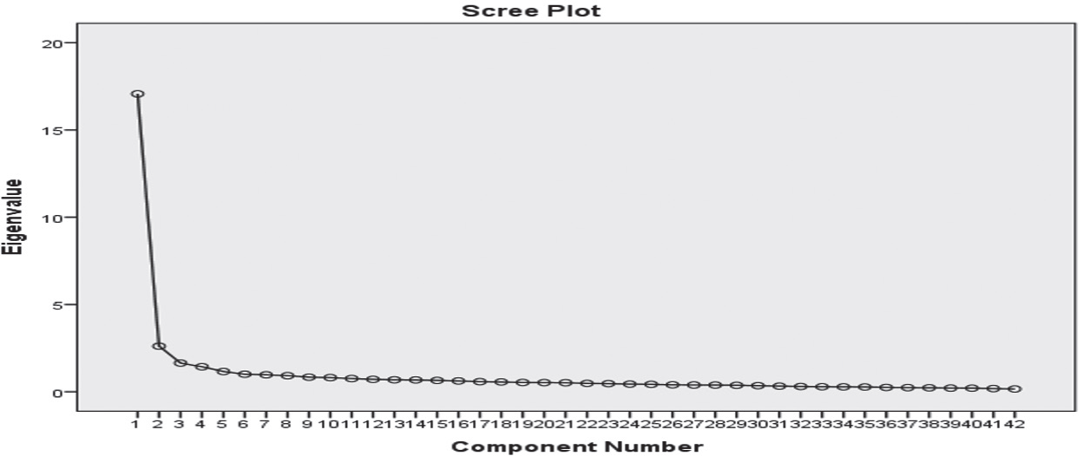

**Figure 1.** Scree plot graph

1. The text should not exceed 30 pages including references.
2. Citations should be given in the text and in parentheses according to APA 7 rules. In-text citations should be in the form of (Aydemir, 2014) for single-author works, (Can & Ulaş, 2003) for two-author works, (Kul, Seven & Deniz, 2016) for three-author works, and (Korkmaz et al., 2018) for works with more than three authors. When referring to the works of an author published in the same year, it should be given as (Yılmaz, 2014a, 2014b).
3. References should be written in alphabetical order. All references used should be written in the original language.

Examples of bibliography writing are given below.

**Article:** Author's surname, Author's initials (for articles with 3 or less authors, all authors should be indicated; for articles with more than 3 authors, the first 3 names should be indicated), (Year of publication). Title of the article. *Name of the Journal in which the article is published*, Issue (Volume), page no. Doi number if available.

Ay, İ., Bekler, B., Bekler, S., & Dal, M. (2024). Bibliometric Analysis of Academic Studies on BREEAM with VOSviewer Software Program. *Engineering Applications*, *3*(3), 185–202.

Ay, İ., Bekler, S., Bekler, B., & Dal, M. (2024). Taş Alterasyonları Konusunda Yapılmış Akademik Çalışmaların VOSviewer Yazılım Programı ile Bibliyometrik Analizi. *Kültürel Miras Araştırmaları*, *5*(1), 15–31. https://doi.org/10.59127/kulmira.1495257

Burkut, E. B., & Dal, M. (2023). Systematic Literature Review and Scientific Maps on Ecological Architecture and Eco-Architecture. *International Journal of Pure and Applied Sciences*, *9*(2), 369–380. https://doi.org/10.29132/ijpas.1365407

Burkut, E. B., & Dal, M. (2024). Analysis of Articles on Occupational Health and Safety with Scientific Mapping Techniques in WoS & Scopus Database (2000-2023). *Digital International Journal of Architecture Art Heritage*, *3*(1), 1–13.

Burkut, E. B., Tekin, S., & Dal, M. (2025). Art and Museums in the Digital Age: An Overview of the Concepts and Spatial Design. *Online Journal of Art and Design*, *13*(1), 73–87.

Dal, M., Burkut, E. B., & Karataş, L. (2023). Analysis of Publications on Earthquake Research in Architecture Category and Analysis with R Studio-Biblioshiny Software. *Journal of Architectural Sciences and Applications*, *8*(Special Issue), 183–197. https://doi.org/10.30785/mbud.1333876

Tekin, S., Burkut, E. B., & Dal, M. (2024). Culture and arts management: A bibliometric analysis using software. *Cultural Heritage and Science*, *5*(1), 62–74. https://doi.org/10.58598/cuhes.1471765

**Book:** Author's surname, Author's initials. (Year). *Title of the book* (number of editions). Place of Publication Publication House

Öcal, A. D., & Dal, M. (2012). *Doğal Taşlardaki Bozunmalar*. İstanbul: Mimarlık Vakfı İktisadi İşletmesi.

Kline, B. R. (2005). *Principles and practice of structural equation modeling* (Second edit). NY: The Guilford Press.

**Book chapter:** Author's surname, Author's initials. (Year). Chapter title. Surname of the Editor (Ed.), *in the book title* (page range). Place of Publication Publication House

Ay, İ., Tekin, S., & Dal, M. (2024). Yeşil Bina ve Sürdürülebilirlik Literatürünün Gelişimi: 1999’dan Günümüze Bibliyometrik Bir Bakış. In M. Dal & İ. Ay (Eds.), *Mimarlık Uygulamaları ve Araştırmaları* (pp. 5–39). BİDGE Yayınevi.

Bekler, S., Ay, İ., Dal, M., & Bekler, B. (2024). Bilimsel Bir Bakış: Küresel İklim Değişikliği ve Sürdürülebilirlik Alanındaki Araştırma Trendleri (1992-2024). In M. Dal (Ed.), *Mimarlıkta Güncel Araştırma, Tasarım ve Yöntem-2024* (pp. 1–24). Livre de Lyon.

**Proceedings:** Author's surname, Author's initials. (Year). Title of the paper. *Name of the event where the paper was presented*, Page.

Ay, İ. (2024). Akıllı Ev Sistemleri Üzerine Bibliyometrik Bir Analiz: Web Of Science Tabanlı Bir Çalışma. *III. International Fırat Scientific Research Congress*, 114–121.

Ay, İ., & Dal, M. (2024). 1989’dan Günümüze Dijital Mimarlık: Akademik Yayınların Bibliyometrik Analizi. *International Science and Art Congress*, 190–198.

Tekin, S., Ay, İ., & Dal, M. (2025). Intersection of Cultural Memory: Bibliometric Analysis of Museum and Music Studies: Web of Science Database. *II. International Perge Scientific Studies Congress*, 165–173.

Tekin, S., Burkut, E. B., & Dal, M. (2024). Akıllı Şehirler ve Sanat Alanlarındaki Akademik Çalışmaların Bibliyometrik Analizi. *Munzur International Scientific Research And Innovation Congress*, 288–297.

Tekin, S., Dal, M., & Ay, İ. (2025). Museums As A Confluence of Culture and Art: A Bibliometric Analysis of The Scopus Database. *II. International Perge Scientific Studies Congress*, 174–182.

Özmen Halis, E. G., Ay, İ., & Dal, M. (2025). The Interaction Between Culture And Artificial Intelligence: An Evaluation From A Bibliometric Perspective. *II. International Perge Scientific Studies Congress*, 153–162.

Özmen Halis, E. G., Dal, M., & Ay, İ. (2025). Bibliometric Analysis of Digital Heritage Literature: Trends and Findings of Academic Publications With Web of Science Data. *Ases II. International Culture, Art and Literature Congress*, 5–14.

Özmen Halis, E. G., Tekin, S., Erdoğan, J., Özer, D., Alp Dal, N., Ay, İ., & Dal, M. (2025). Analysis of Bibliometric Studies From 1969 to the Present: Bibliometrics with Scopus Data. *Abant 4th Internatioınal Conference on Current Academic Studies*, 225–234.

**Internet source:** Source (Year). *Publication name.* (Date and address accessed from the Internet)

TÜİK (2014). *Hanehalkı bilişim teknolojileri kullanım araştırması 2014*. (Retrieved on 16/06/2015 from http://tuik.gov.tr/PreHaberBultenleri.do?id=16198.).